ABA Services
Employee Handbook
For BTs and RBTs

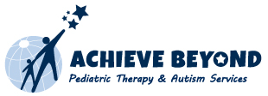
225 Broadhollow Road, Suite 402 • Melville, NY 11747 • Tel 631.385.7780 • 646.839.5789 www.achievebeyondusa.com
ABA Services Employee Handbook
For BTs and RBTs
Table of Contents:

- Introduction………………………………………………………………………………3
- Who to Contact…………………………………………………………………………..5
- How Services Begin for a Family……………………...………………………………...7
- Sample Parent Welcome Letter…………………………………………………………8
- Starting a Case………………………………………………………………………….12
- When Services Begin.…………………………………………………………………...14
- What is Pairing? .……………………………………………………………………….15
- Home Therapy Rules…………………………………………………………………...16
- Ethics…………………………………………………………………………………….17
- HIPAA Law…………………………………………………………………………..…19
- Billing……………………………………………………………………………………20
- Self-Services……………………………………………………………………………..26
- Helpful Hints/Troubleshooting………………………………………………………...30

- References……………………………………………………………………………….32

INTRODUCTION
Congratulations on beginning your career at Achieve Beyond! By accepting a position as a Behavior Technician or RBT, you are showing that you are committed to improving the health and lives of children with autism and other special needs. As an employee of Achieve Beyond, it is important to always maintain a high level of professionalism as we are representatives of the agency as well as ambassadors for ABA.
What this means is that we are responsible to disseminate accurate, truthful and meaningful information on Applied Behavior Analysis and Autism Spectrum Disorder. This includes basic definitions, applications, personal experiences and valid resources. For example:
What is Applied Behavior Analysis (ABA)?
Applied behavior analysis is the science of learning and behavior. It can help us understand how a behavior works, how it’s affected by the environment, and how learning takes place. Positive reinforcement is one of the main components of ABA. By understanding the three term contingency, antecedents-behavior-consequences, we are able to make adjustments before and after a behavior that can result in a desired change. For example, throwing out all of the junk food in your home can be an effective antecedent change for a successful diet. In addition, purchasing a new pair of jeans in a smaller size can be the consequence (positive reinforcement) of weight change. By adjusting the before and after consequences, the likelihood of successful diet is increased.
Is ABA only used as a therapy for autism?
Yes, ABA has been found to be effective in other areas such as animal behavior, behavioral gerontology and medicine, other developmental disabilities, health and sports issues, organizational behavior management, parent training, performance management, sex therapy, and verbal behavior. However, ABA is recognized as a medically necessary treatment for autism spectrum disorder.
What is Autism Spectrum Disorder (ASD)?
The DSM-5 Diagnostic Criteria for Autism Spectrum Disorder (F84.0) defines ASD as demonstrating:
- Persistent deficits in social communication and social interaction across multiple contexts
- Restricted, repetitive patterns of behavior, interests, or activities
- Symptoms must be present in the early developmental period
- Symptoms cause clinically significant impairment on social, occupational, or, other important areas of current functioning
- These disturbances are not better explained by intellectual disability (intellectual developmental disorder) or global developmental delay
Since autism spectrum disorder includes such a wide range of variability and symptoms, no two clients will be the same. The DSM-5 also includes definitions for the severity of symptoms; Level 1 “Requiring support”, Level 2 “Requiring substantial support”, and Level 3 “Requiring very substantial support.”
Why is ABA an effective treatment for ASD?
ABA is considered an evidence-based best practice treatment for autism by the US Surgeon General and the American Psychological Association. This means that it is scientifically tested for its usefulness, quality and effectiveness. ABA is a proven strategy for teaching appropriate and functional replacement behaviors, increasing positive behaviors, reducing maladaptive behaviors, and increasing academic, cognitive and adaptive skills (autismspeaks.org). By focusing on motivation and reinforcement, these skills can be then maintained and generalized into naturalistic settings.
How is ABA therapy applied?
There are many different techniques used in ABA therapy that can be applied in almost any setting. Discrete trial teaching (DTT) can be done in a home or clinic in which the child and therapist work on emerging skills that require intense repetition such as identifying objects to making a sandwich. Natural environment training (NET) can be done at home, school, community, even a playground as the focus is to teach skills where they will be used most naturally. These sessions may look different each time, although they should all include “work time”, “break time”, data collection, and most of all, creativity. NET is child-led, which means the child is guiding the session and their motivation. Verbal Behavior (VB) therapy teaches communication and language. It begins by teaching a child to echo, request, label and respond or answer questions within their environment. Because communication results in the child ‘gaining something’, it is often reinforced automatically in the natural setting. This can be achieved through verbal, gestural, or written language. Teaching skills using a combination of DTT, NET and VB have been most effective for maintaining and generalizing skills.
Who can implement ABA therapy?
A behavior therapist (BT) or a Registered Behavior Technician (RBT) can provide ABA therapy under the supervision of a Board Certified Behavior Analyst (BCBA). A BCBA holds a master’s degree (often in special education or psychology), must go through extensive training and supervised fieldwork, and pass a board certified behavior analyst certification exam given by the Behavior Analysis Certification Board (BACB). Only the BCBA can complete an assessment regarding the behaviors and skills of the child, create an individualized ABA program with goals, and supervise/analyze the progress of the child. A BCBA must supervise at least 10% of the hours that direct ABA therapy that are implemented by a BT/RBT.
The BT/RBT implements the program that is created by the BCBA and takes data of the child’s progress. A BT must complete a 20-40 hour intensive training program which includes the basics of ABA, teaching strategies and implementation. In addition, an RBT completes a specific supervision period and must also pass a certification exam through the BACB. For more information on becoming an RBT, please see: https://www.bacb.com/rbt/.

How can we measure progress?
Data, data, data! Data on skill acquisition and behavior reduction should be recorded and analyzed regularly. Whether it is trial by trial, probe, ABC, duration, data must always be taken and graphed. Graphing daily or weekly (as determined by the BCBA) will reflect the child’s progress, and indicate to the supervising BCBA if any changes need to be made or new goals need to be added. Using visual graphs makes it easier to see even the smallest progress.

WHO TO CONTACT

Erin Geiselmann- Assistant Clinical Director
egeiselmann@achievebeyondusa.com
- provides clinical advice
- troubleshoots problems

Tara Karen- Regional Operations Director
Phone: 631-385-7780 ext. 629
tkaren@achievebeyondusa.com
- oversees programs for New York, New Jersey, Connecticut and California
- fields ethical questions

New York/New Jersey/California:
Ashley Dockery- Provider Relations Manager
Phone: 631-385-7780 ext. 667
adockery@achievebeyondusa.com
- Escalated issues or concerns regarding cases
- Payroll questions
- salaried providers
- supervision monitoring

Amanda Nocella- Staffing Coordinator
Phone: 631-385-7780 ext. 697
anocella@achievebeyondusa.com
- staffing/re-staffing
- schedules and availability
- on-hold billing and billing questions
- FDAs (first day of attendance forms)
- Email lock-outs/password resets

Wendy Zuniga- ABA Case Manager
Phone: 631-385-7780 ext. 664
wzuniga@achievebeyondusa.com
- Corresponds with insurance companies
- authorized /remaining units
- send reassessment reminders

Stefanie Xuereb- Client Services Specialist
Phone: 631-385-7780 ext. 626
sxuereb@achievebeyondusa.com
- outreach
- intake
- parent contact for all issues

New Jersey:
Amy Iturburo- Client Service & Provider Relations Coordinator
Phone: 888-261-1110
aiturburo@achievebeyondusa.com
- staffing
- intake
- PR on-holds

Virginia/DC:
Gina M. Ballone, MS, BCBA, LBA- Clinical Director of ABA Services
Phone: (703) 237-2219 ext. 207
gballone@achievebeyondusa.com
- supervises all clinical staff
- provides RBT Trainings
- troubleshoots problems
- collaborates with RS for clinic events
- works closely with Admin on daily operations
- assists ABA Program Coordinator

Jad Ibrahim, MBA, RBT- ABA Program Coordinator
Phone: (703) 237-2219 ext. 213
jibrahim@achievebeyondusa.com
- coordination of new clients
- scheduling
- support clinician for Central Reach

Laura Faine- Virginia Program Manager
Phone: (703) 237-2219 ext. 210
lfaine@achievebeyondusa.com
- payroll inquires
- timesheet inquiries
- reimbursement inquiries
- work email inquiries

sxuereb@achievebeyondusa.com
- intake

- HOW SERVICES BEGIN FOR A FAMILY

Parents will either call into our office or email our “info line” looking for more information about our ABA program. Our Client Services Specialist will reach out to the parents to get the intake process started. To get the process started, the office will need

- A copy of the insurance cards
- An up to date prescription with an ASD diagnosis
- An evaluation report that diagnoses the child with Autism

Once Client Services receives these items they will call the insurance company to verify the ABA benefits. If the child has ABA benefits, the parents will be sent an intake packet that needs to be completed. If the child does not have ABA benefits the parents have an option of paying privately or discuss with their companies’ human resources representative to change insurance coverage.

Once the packet has been completed and sent back to client services it will be checked over to make sure the packet is filled out in its entirety and we have the evaluation, prescription and insurance cards. After everything is audited, client services will reach out to the insurance company for an assessment authorization. Authorization turnaround time can take anywhere from 2-15 business days.

After the assessment authorization is received, staffing will send out an email to BCBA for assessment. The BCBA will go in, complete the assessment, write up the report, and recommend the number of hours that are medically necessary to meet the child’s goals. This can range between 10 to 40 hours per week. The clinical director will then review the report and give client services the “OK” to send the report to the insurance company and request the authorization for ongoing services. Again, the turnaround time can take anywhere from 2-15 business days.

While we are waiting for the authorization for services, client services will send the report to the family to review and sign, and advise availability. During this time, the staffing coordinator will look for a BT/RBT with the availability requested. When authorization is received, the staffing coordinator will forward the staffing email to the BT/RBT and BCBA. If no BT/RBT is assigned, staffing will hold on to it until they find a BT/RBT.

See below for parent Welcome Letter that is sent before the above steps are completed that outlines the policies and procedures expected:
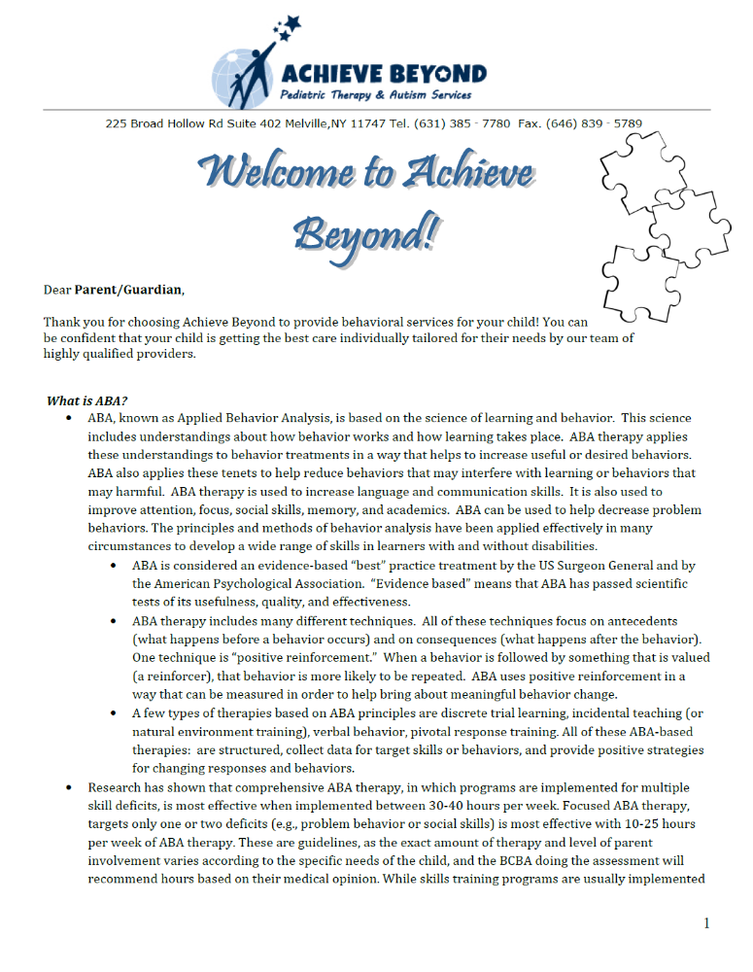

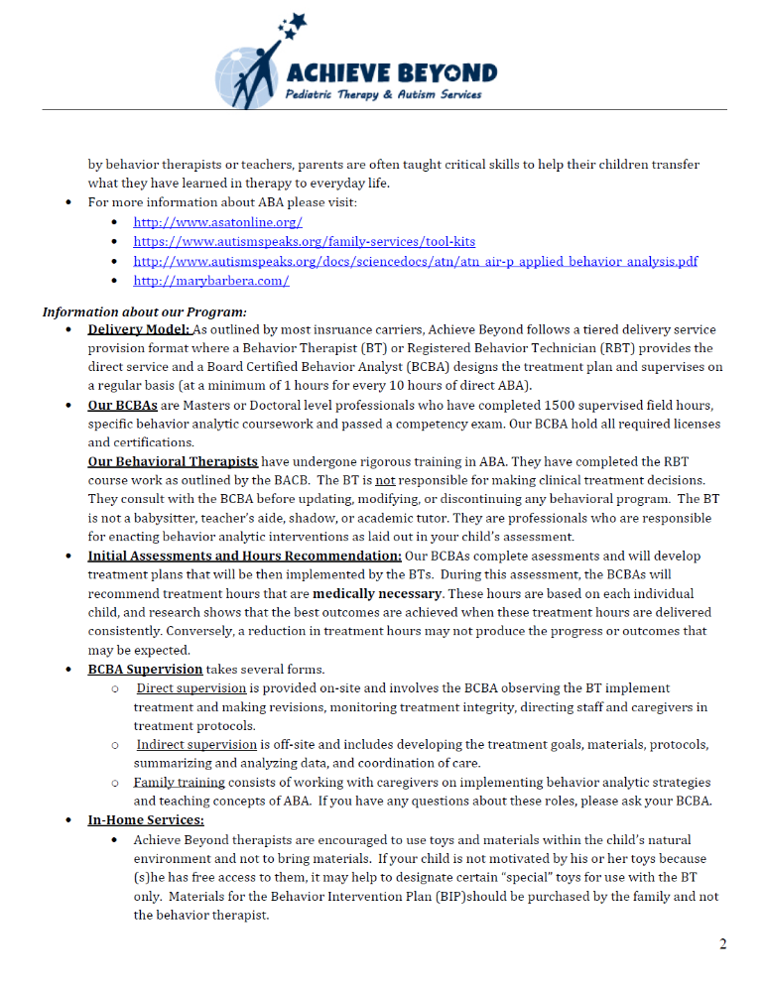

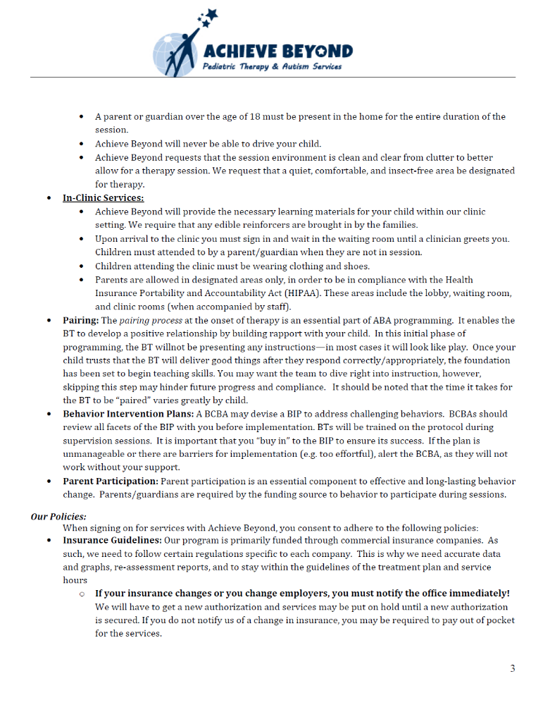

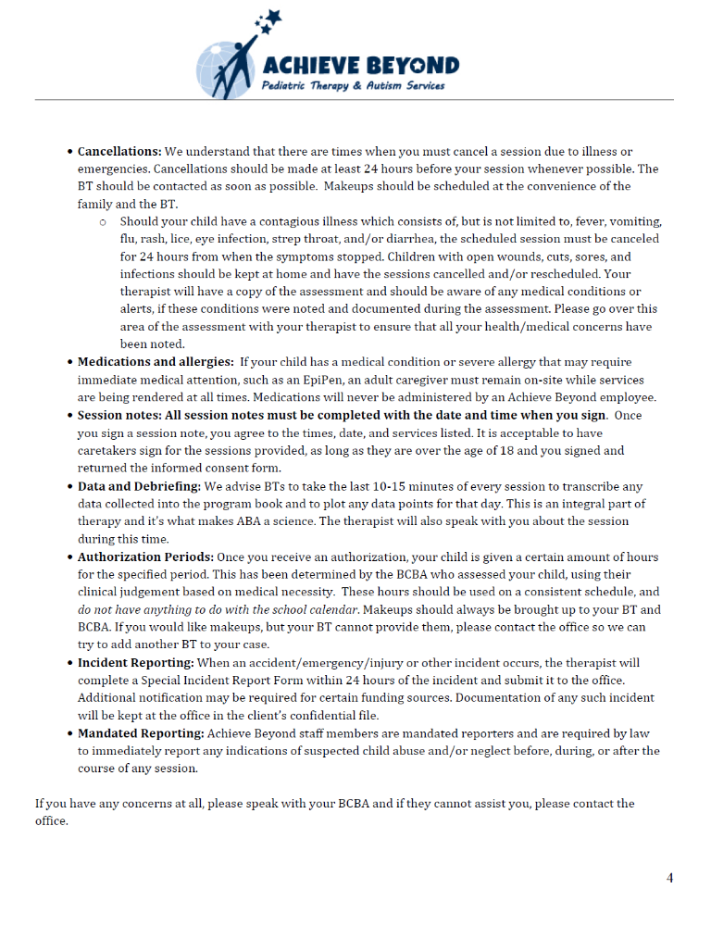

STARTING A CASE
Getting Started
Once training and all of your initial paperwork is complete and reviewed by our credentialing department you will be made compliant. Being compliant means that all necessary paperwork has been submitted, including your CPR certification, and a background check has been completed. You cannot take a case until you have been made compliant by our credentialing department!

Once you are made compliant, our staffing coordinator will then submit a request to have an Achieve Beyond email account generated. Your Achieve Beyond email is HIPAA compliant and all correspondence with clients, your BCBA, and anything work-related needs to be sent through this email only. Your initial email congratulating you on your compliance will also have instructions to set up your email on your phone and desktop so you will have constant access to new and available cases! The email also requests for you to send your updated resume and availability as well so we can be proactive with finding you some cases before we speak with you.

How will I be notified of available cases?

As cases become available, the staffing department will send out a “blast email” to your Achieve Beyond email with basic information regarding the case, such as city/town of child’s residence/where services will occur, # of hours approved per week and desired schedule if available. It may also include child’s age and gender. It is important to check your email regularly for available cases as they are often staffed quickly and are on a first come first serve basis. For information on using the outlook app on your phone, please see the provider page: https://www.achievebeyondusa.com/index.php/component/content/article?id=647

What if I am interested in a case?

If you are interested in a case, please reply promptly and indicate which case you would like to be staffed on. It is important that you are available for the approved number of hours and scheduled times, and able to get to the location before replying to the email. Please be aware that many cases are first come, first serve.

Before accepting a case, reach out to the staffing coordinator in order to request the address. With this information you can cross reference the address in Google Maps at the time of the case to ensure the distance and travel time will be acceptable. We never want to begin a case and then disrupt it quickly because you did not do your research. There is a 2 week transition period to re-staff a case, and in the meantime, the child is missing out on therapy.

DO NOT accept a case without a clear understanding of expectations and ability to fulfil the hours and locations. Please ask questions if unsure!

Getting staffed on a case:

If you are selected to be the BT/RBT on a case, you will receive a staffing email which will include: the child’s information (name, address, date of birth, parent’s phone #, etc.), the BCBA information, and the child’s assessment. Please read through all of this thoroughly before contacting the BCBA.

You must contact the BCBA within 24 hours of receiving the staffing email. Do not call the family without speaking to the BCBA first! This is very important as they will provide you with additional information regarding the case. Let the BCBA know if this is your first case. Your BCBA is there to support you, answer questions, and practice/role play. That is why that phone call prior to calling the family is so very important.

After speaking with the BCBA, call the family:

In this initial phone call, introduce yourself, give any related experience, and schedule the first session and ongoing sessions. Ask parents questions regarding the child’s likes, dislikes and strengths. It is important to leave a good first impression. Do not focus on your lack of experience, instead focus on the BT/RBT training obtained through Achieve Beyond. Be enthusiastic!

While every family and situation is different, here’s an example of a possible initial phone call to the family:

BT: Hi! Can I speak with Mr. or Mrs…? This is Jon from Achieve Beyond. I wanted to call and introduce myself since I will be working with Jake as his behavior therapist. I’ve read through his assessment so I understand he likes Paw Patrol? Is there anything else you’d like to share about him? I’m really excited to meet all of you and get to know Jake. Would you like to set up our first session? I spoke with the BCBA and she mentioned that Tuesdays work best for you? Did you have any questions for me? Great, see you then!

When the first session is scheduled, be sure to have your bills printed. A completed FDA must be forwarded to staffing to advise of schedule moving forward.

It is important that all hours are utilized within the authorization period as they are medically necessary for the child to succeed in our program and progress through their goals.

Sample FDA (First Date of Attendance Form):

A completed and signed FDA must be sent in the day after the first session.

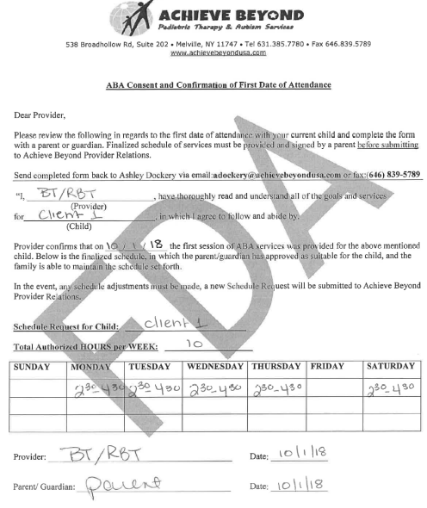

WHEN SERVICES BEGIN
Leading up to that first session and thereafter:

- Be on time. If you are running late, advise the family as soon as you know.
- Always be respectful of the family’s home, expectations and space. You are at their home for several hours a week, you are a guest.

- The first few sessions consist of pairing, get to know your child and the family. Play and have fun!
- Once pairing is established and you begin instructional control, you should have the program book to review with your BCBA and begin running programs.
Pairing with the child looks like play! You are often sitting next to them, playing alongside, making comments or handing over toys. These are child-led sessions and there are no demands placed initially. Once the child is more comfortable with you, then the items of interest can be slowly transitioned to the work area and demands can be slowly introduced. Superbills must be completed for these sessions and can include data on behaviors and preferences of activities the child is drawn to.

Pairing Learning with Reinforcement

Non-Contingent Delivery of Reinforcers

- No instructional demands
- All the child has to do is accept items (food, drink, toy, etc.) from you
- Frequently approach and move away from the child when delivering reinforcers
- Pair your voice with the item/reinforce you are delivering
- Once approaching has been faded, the child should be approaching the instructor seeking reinforcers
- Once the child is seeking out the instructor, the instructor should start to move closer to the teaching table
- Begin to place preferred items on the teaching table and chair

Moving to Contingent Delivery of Reinforcers

- Once the child is seeking out the instructor to access reinforcers and he/she is going to the table and chair or instructional area. be careful not to jump to "all demand all the time" condition. Instead systematically increase the number of demands over time.
- Be sure to start all sessions with pairing and throughout the session, conduct additional reinforcer assessments

Steps 1-4 can take 10 minutes, 20 minutes, a day, a few days…. be patient!

Program Books are created by the BCBA based on the assessments. These goals are carefully chosen and are included within the book with specific instructions regarding implementation and data collection. These must be followed as written. BTs are not allowed to add, remove, or make changes to any programs. If there are any questions, always refer to your BCBA.
Program books must be in the home once pairing is complete so programs can be started immediately. If not, you must contact the office to advise.
Program books must never be removed from the home!
Removing a program book from the home can result in a HIPAA violation as well as it makes it difficult for the BCBA to access it for updates or assessments.
Materials are mostly provided by the family and kept in the home, however, some items may be provided by the BCBA. You are not responsible to purchase any materials, cards, toys, edibles, etc. If you feel that you need something advise the BCBA and they can get it for you or request it from the family.
Direct Supervision by your BCBA can take place every week or every two weeks. They are required to supervise at least 10% of the hours of direct therapy. Always advise your BCBA of any schedule changes or makeups so they can plan supervision accordingly. During this time, the BCBA will review the program book, add or remove programs, probe new goals, and discuss overall progress. They rely on the graphs and data collection to make these decisions so it is important that these are completed and accurate.
Consent Forms signed by the parents are required for any therapy to be implemented in the community. Consent forms are also required to transmit information via text, taking photographs and video recording and/or conferencing. Otherwise, all correspondence between the client, the agency and the BT must be made through the Achieve Beyond email to adhere to the HIPAA law and protect our client confidentiality.
One month after starting a case, we do offer a webinar in which you can review data collection, teaching strategies, and additional procedures needed to provide ABA therapy effectively to our clients. Although not mandatory, this could be a useful review of important topics and may be helpful for your sessions.

Pairing Learning with Reinforcement

Non-Contingent Delivery of Reinforcers

- No instructional demands
- All the child has to do is accept items (food, drink, toy, etc.) from you
- Frequently approach and move away from the child when delivering reinforcers
- Pair your voice with the item/reinforce you are delivering
- Once approaching has been faded, the child should be approaching the instructor seeking reinforcers
- Once the child is seeking out the instructor, the instructor should start to move closer to the teaching table
- Begin to place preferred items on the teaching table and chair

Moving to Contingent Delivery of Reinforcers

- Once the child is seeking out the instructor to access reinforcers and he/she is going to the table and chair or instructional area. be careful not to jump to "all demand all the time" condition. Instead systematically increase the number of demands over time.
- Be sure to start all sessions with pairing and throughout the session, conduct additional reinforcer assessments

Steps 1-4 can take 10 minutes, 20 minutes, a day, a few days…. be patient!

HOME THERAPY RULES
DO’S… DON’T’S…
Keep a consistent schedule and an enthusiastic attitude | Constant lateness and absences are unprofessional
Be respectful of others’ space, expectations and cultures | Talk condescendingly to the client or family or discuss personal beliefs
Encourage parent and/or sibling participation and model programs when appropriate | Leave a child unattended as this could result in dangerous behaviors or injury
Follow the programs, collect data and graph consistently to show progress | Make changes to programs as this can only be done by the BCBA
Be mindful of keeping a professional therapist relationship at all times | We are not babysitters, confidants, travel companions, drivers, or academic tutors
Show an interest in the child’s school day and outside activities to create a more individualized program | Share personal social media contacts, such as Facebook or Instagram, as it could be a confidentiality breach
Respond to all phone calls, emails and texts from your client, BCBA or Achieve Beyond within 24 hours | Use your phone for personal phone calls or texting during sessions
ETHICS
Because of the nature of our work, the access to confidential information and the vulnerability of our clients, it is important that all ABA professionals adhere to the BACB’s Professional and Ethical Compliance Code for Behavior Analysts (www.bacb.com/ethics/ethics-code). As previously discussed, as employees of Achieve Beyond we must maintain a high level of professionalism. Failure to comply with this Code of Ethics can lead to serious complications and can result in disciplinary action, dismissal from employment and/or loss of licensure by The Board. While it is important to be familiar with the entire code, here’s a summary of codes that relate closely to your position as a BT/RBT:

Code 1.0- Responsible Conduct of Behavior Analysts:
Behavior analysts and RBTs are truthful and honest and arrange the environment to promote similar behavior in others (Code 1.04). They rely on knowledge based on science and behavior analysis, and should maintain knowledge of current scientific and professional information (Code 1.01, 1.03). It is important that behavior analysts and RBTs provide services, teach and conduct research in an ethical manner within their boundaries of competence (Code 1.02).
In addition, behavior analysts and RBTs must not discriminate against age, gender, race, culture, ethnicity, religion, language, etc. The relationship with the client must always remain professional, avoiding exploitive and multiple relationships, and conflicts of interest (Code 1.05, 1.06, 1.07). This includes refraining from any sexual relationships with clients, students or supervisors, and not accepting gifts or invitations to personal occasions from clients as this may affect biasness in treatment.
Code 2.0- Behavior Analysts’ Responsibility to Clients:
Behavior analysts and RBTs are required to identify the primary beneficiary of services in any given situation and advocate for his or her best interest (Code 2.02). The rights of the client are paramount and behavior analysts and RBTs must support the legal rights of the client, maintain confidentiality and records, and appropriately document their professional work for replication and accountability (Code 2.05, 2.06, 2.10). Written consent by the client must be provided prior to disclosing confidential information (Code 2.08).
Code 3.0- Assessing Behavior:
A current assessment must be completed by the behavior analyst to recommend and develop a behavior change plan. Behavior analysts and RBTs are obligated to collect and graphically display the data in a manner in which it can be used for further development of the plan (Code 3.01).
Code 4.0- Behavior Analysts and the Behavior-Change Program:
Behavior analysts and RBTs must minimize the use of potential reinforcers that may be harmful to the health and development of the client (Code 4.10).
Code 6.0- Behavior Analysts’ Ethical Responsibility to the Profession of Behavior Analysts:
Behavior analysts and RBTs have an obligation to the science of behavior and profession of behavior analysis. This includes upholding the values, ethics and principles of behavior analysis, and disseminating information promoting behavior analysis (Code 6.01, 6.02).
Code 7.0- Behavior Analysts’ Ethical Responsibility to Colleagues:
Behavior analysts and RBTs must promote an ethical culture in their work environment. If there is a possible legal or ethical violation, all attempts must be made to resolve the issue by documenting or reporting to the appropriate authorities (Code 7.01, 7.02a). If the client’s rights are being violated or there is potential for harm, then steps must be taken immediately to protect the client (Code 7.02b).
Code 8.0- Public Statements:
Behavior analysts and RBTs do not make public statements that are false, deceptive, misleading, exaggerated or fraudulent (Code 8.01). Only behavior analytic services can be performed and advertised (Code 8.05). Appropriate permissions and credits need to be obtained prior to presenting information that is not original (Code 8.02).

Code 9.0- Behavior Analysts and Research:
Research and plan implementation must be consistent with all applicable laws and professional standards, including the laws and regulations relating to mandated reporting requirements (Code 9.01).
Code 10.0- Behavior Analysts’ Ethical Responsibility to the BACB:
Behavior analysts and RBTs must adhere to this Code and all rules and standards of the BACB (Code 10.0). Any information provided on applications to the BACB must be truthful and accurate or may result in disciplinary action (Code 10.01). Course work should be completed in accordance to the BACB standards, and if dishonesty is observed during an exam, it should be reported immediately (Code 10.04).
HIPAA LAW
HIPAA (Health Insurance Portability and Accountability Act):

This is a federal law to protect privacy of a patients’ PHI (personal health information). It provides for physical and electronic security of PHI. Violation categories can be broken down by “Reasonable Cause” and “Willful Neglect” and can result in the following penalty amounts:

Violation | Amount per Violation | Violations of an Identical Provision in a Calendar Year
Did not know | $100-$50,000 | $1,500,000
Reasonable Cause | $1,000- $50,000 | $1,500,000
Willful Neglect- Corrected | $10,000- $50,000 | $1,500,000
Willful Neglect-  Not Corrected | $50,000 | $1,500,000

Some examples of PHI (Personal Health Information) include:
- name
- postal address
- phone/fax number
- full face photos and other comparable images
- account numbers
- social security numbers or any unique ID#s
- medical record number
- email/ip or url address
- vehicle identifiers/license numbers
- device identifiers/serial numbers
- health plan beneficiary name/number
- all elements of dates except year
- finger/voice prints, etc.

If in doubt, protect the document… better to be safe than sorry!

How can we make sure we are in compliance with HIPAA law?

- Always use the achievebeyondusa.com email as this is secured server and HIPAA compliant.
- Emails that are accessible on the phone must be password protected.
- In addition, any texts between parent, BT/RBT, and BCBA should not include child’s name/address.
- Parents may mention their child’s information on a text, however, Achieve Beyond employees may not text this information.
- Follow up any texts with phone calls or through email.
- If approved for remote supervision, only the Zoom Meeting App can be used as Achieve Beyond has a HIPAA compliant account. For more information, please contact the provider relations team.
- In order to further protect the privacy of the client, program books are never to be removed from the home, and any superbills or documents regarding treatment should never be left in a place that is easily seen or accessible.

Make sure your bills and all case information is through the Achieve Beyond email!
If texting, make sure there is no identifying information, including names.

BILLING
What are superbills/session notes?
This is a billing statement that is submitted to the insurance company for payment of provider services. These are individualized for each client and include the insurance company name and ID #, the billing units, sections for supervision hours and data reporting, as well as a section for BT/RBT, BCBA, and parent signatures. Billing units are specific to each insurance company and services can only be billed within those time increments. For example, if the billing increments are 30 minutes, you cannot bill for a 15 minute increment in services.
How should a superbill be completed?
A superbill must be completely filled out by the end of the session, always have the parent/guardian sign bill before leaving The last 10 minutes of the session should consist of graphing, finishing the superbill, getting a signature and debriefing the family. Make sure every section of the superbill is completed and handwriting is legible. These are submitted to the insurance companies for payment of services and must include the date, time of services, location of services, supervision info if applicable, and data (frequency counts, duration counts, % correct, ABC, etc.)!! All superbills/session notes must be signed by the BT/RBT, parent, and BCBA before they are submitted. Parent must sign (unless there is documented consent for another adult to sign) and check the box indicating any change in insurance at every session and should never be asked to sign a blank bill.
Every section of the superbill must be completed!
SUPERBILL REFERENCE GUIDE
- DATE OF SERVICE- Please write the entire DOS clearly- Day-Month-Year
- PATIENT NAME AND MEMBER ID#- This section of the superbill is pre-filled out for you.
- START TIME- Please write the entire time- Hour: Minutes and don’t forget to circle AM or PM- if the start time is 4 o’clock please write 4:00, don’t forget the minutes!
- END TIME- Please write the entire time- Hour: Minutes and don’t forget to circle AM or PM- if the start time is 4 o’clock please write 4:00, don’t forget the minutes!
- LOCATION- Please circle the location- typically it’s “HOME”.
- HOURS- This is where you would write your TOTAL HOURS for the session- If you were supervised for part of the session, you would still put the entire time you were there.
- SUPERVISED TIME- If your BCBA supervised you during the session please make sure your time matches the BCBA’s time. Don’t forget to circle am or pm
- NOTES SECTION- Please include as much information as possible. Data, Data, Data! Goals, behaviors, parent communication. Please see attached superbill as a reference guide.
- INSURANCE- Check the box if insurance has changed, or remains the same. If insurance has changed, please let parents know they need to call us immediately with the new insurance info.
- SIGNATURES- You need to have all THREE signatures in this section- Parent/Guardian signature, BT Signature, BCBA signature- Parents should never be given a blank bill to sign. It is your responsibility to submit your billing once you’ve received it back from the BCBA.

It is the responsibility of the BT/RBT to print out the timesheets and superbills/session notes. You also have the option of coming into the office to print.

See next page for samples of completed superbills/session notes. Numbers on first sample correspond to above.

Sample Superbills/Session Notes:

The numbers on this superbill correspond with the referenced numbers above.

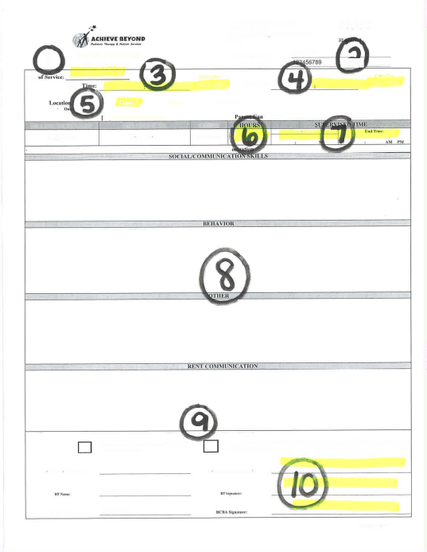

A completely filled out superbill must be submitted for each session.

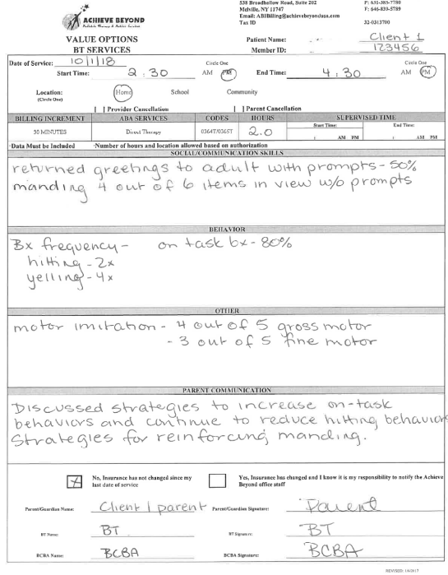
Some examples for the Social/Communication Skills Behavior section could include: manded for 5 items out of view without prompts, tacted 4 out of 5 family members correctly, mastered word puppy and kitten and now has 20 tacts, etc.

Some examples for the Behavior section could include: client attempted to elope from work area 4 times and was blocked and redirected, vocal stereotypy occurred for 80% of the session, etc.
Some examples for the Other section could include: imitated 4 out of 6 gross motor movements, client was able to follow task analysis to step 4 (out of 8) to tie shoes, client imitated modeled fine motor actions 80% of the time with full prompts, etc.
Some examples for the Parent Communication section could include: discussed first/then strategies used for task completion, how parents can generalize skills out of session, client progress, etc.
When should a superbill be completed?
Every session that occurs or does not occur at the scheduled times must have a superbill. This includes the initial sessions for the BT/RBT when the FDA is completed and pairing is occurring. Except for a cancellation of session superbill, all bills must be completely filled in before the parent signs.
A cancellation bill must include the date of cancelled session, who cancelled the session (parent or provider), why the session was cancelled and a signature. The BT/RBT signature alone is acceptable. The parent and/or BCBA signatures are not required. If a makeup is scheduled, this can also be included on this bill.
When and where are the superbills/session notes submitted?
All superbills/session notes and timesheets must be completed and submitted every other Wednesday according to the payroll schedule. An inaccurate timesheet or missing and incomplete bills may be delayed for payment if not resubmitted in a timely manner. Billing cycles run for two weeks from Sunday through Saturday. The timesheets will be emailed by the provider administration team at the start of the payroll period and must include the provider’s name, dates and hours of services and pay rate.
All superbills/session notes must have all signatures prior to being submitted, including the BCBA! If bills need to be faxed or emailed to the BCBA for signatures, it must be done on Sunday or Monday to allow for time to sign and return to the BT/RBT.
All superbills/session notes must be submitted in .pdf format (.jpegs or .gifs cannot be accepted) through the Achieve Beyond email only. Mobile scanning apps such as OfficeLens, CamScanner or TinyScan can be used, however, must be deleted from the phone as soon as possible to adhere to HIPAA law. Billing submitted correctly by the due date will be paid out in the next pay period based on the payroll schedule.

Each state has different email and fax # to send timesheets and superbills. See below:
For NY: All timesheets and superbills/session notes must be emailed to ABIBilling@achievebeyondusa.com OR faxed to 646-839-5789
For NJ: All timesheets and superbills/session notes must be emailed to njbilling@achievebeyondusa.com OR faxed to 646-866-6967
For CA: All timesheets and superbills/session notes must be emailed to ABACABilling@achievebeyondusa.com OR faxed to 646-839-5787
For VA: All timesheets and superbills/session notes must be emailed to

Sample Timesheet:
A completed timesheet must be submitted with the superbills every two weeks.
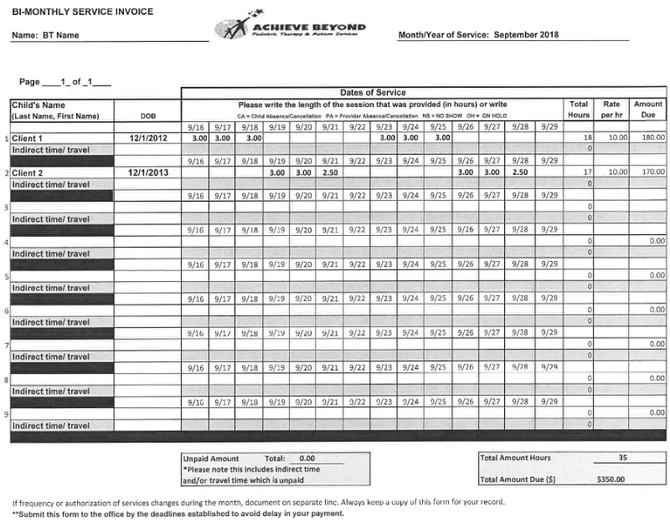

Billing submissions and payroll schedule:
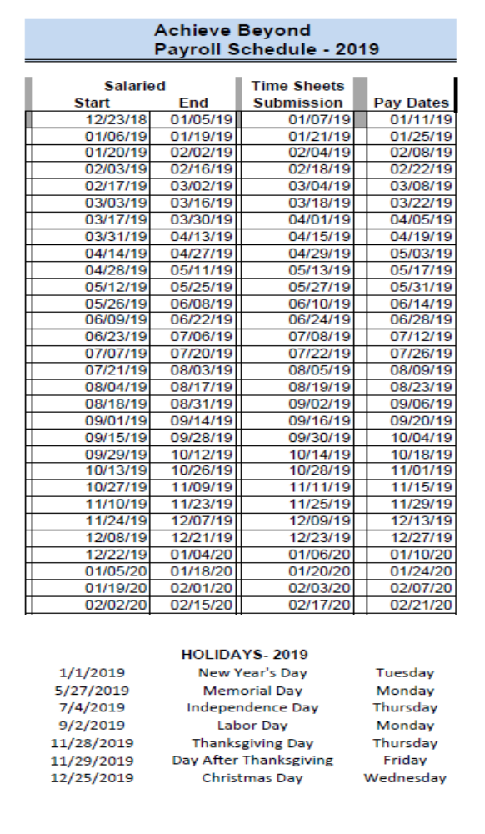

What happens if my superbills/session notes need corrections or I forget to send in?

If a superbill/session note is missing any information, such as date, times, hours, locations, data or signatures, it will be returned for corrections. Any corrections made must be clear and initialed, and returned by the payroll date (usually Wednesday after bills are due). Superbills/session notes that do not get returned within the time period will be paid at the next pay cycle after they are sent correctly.

Why do I need to submit the superbills/session notes on time?

These are sent to the insurance companies to track therapy times and quickly identify and bill the families for copays. Submitting superbills/session notes late will result in large bills for families and possible delay in payment.

Any bills that are submitted with knowingly inaccurate and dishonest information will be considered billing fraud and immediate disciplinary action will be taken. This includes banking hours, overlapping times, altering bills after they are signed, and having the parent sign a blank bill.

SELF-SERVICES

The Self-Services link is the first link located at the bottom left of the Achieve Beyond website (www.achievebeyondusa.com) under Employee Webservices. This is where you can check your paystubs, benefits, PTO (paid time off), the Company Employee Handbook etc. This is what it looks like:

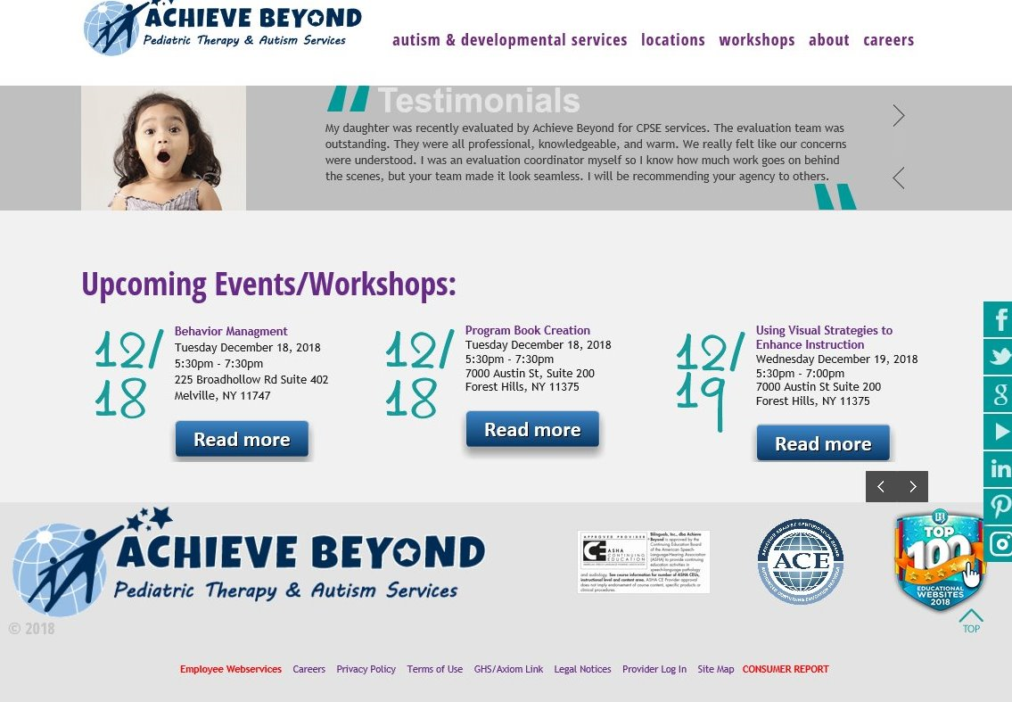

Once Employee Webservices is selected, it brings you to this page. You must select the Employee Self Services tab to continue, which is the 2nd option down.

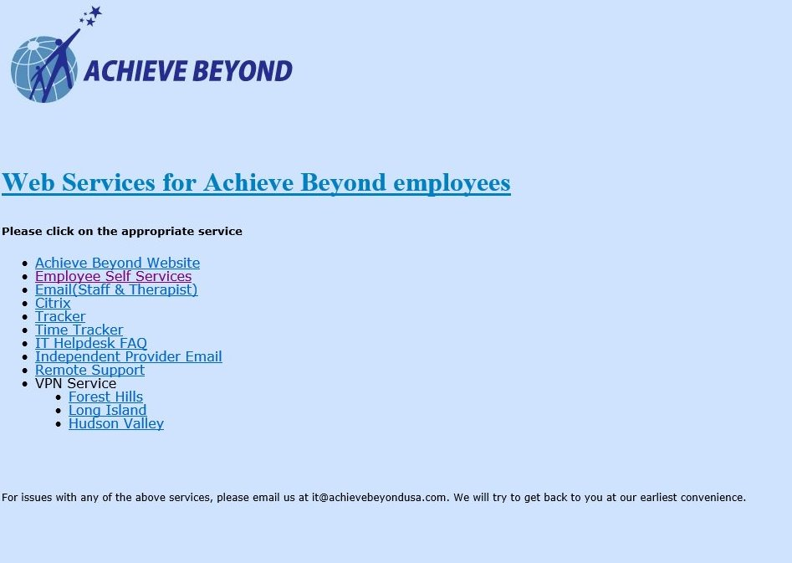

Employee Self-Services will then direct you to the Sage Employee Self Service page where you will have to sign in using your user name and password. Your user name has been assigned by Achieve Beyond, and you can set up your password by registering yourself. When registering as a first time user, you will need to add your social security number.

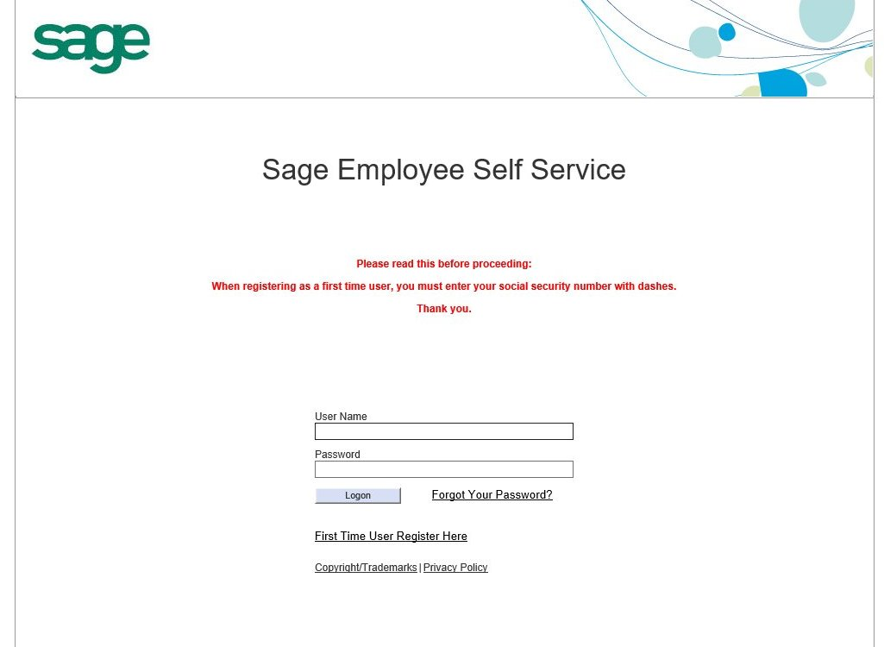

Once signed in, your information will be displayed as follows. This is where you can get your paystubs, benefits, PTO (paid time off), the Company Employee Handbook etc.

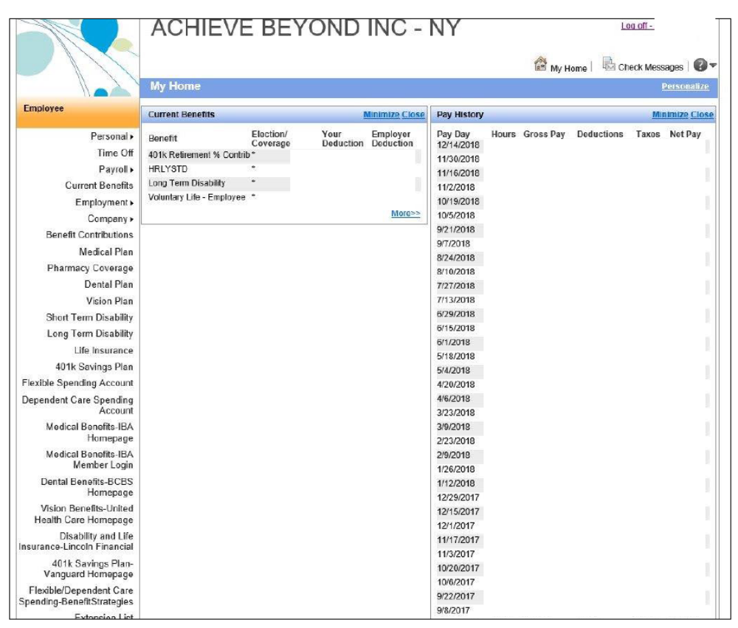

HELPFUL HINTS/TROUBLESHOOTING

- What do I do if I am asked a specific question about a program being run or
anything clinical?

Always refer to the BCBA. You can say to the parent, “I’m going to let the BCBA know your concerns and she/he will get back to you”. In addition, do not make suggestions or criticisms about the programs or BCBA as this is unprofessional and outside of your scope of practice.

- What if a family wants to go into the community?

Many of our clients show deficits in social skills and would benefit from therapy in the community. However, this is only permitted if the insurance company has authorized this, there are specific therapeutic goals that require a community setting, and there is a consent form that is signed by the parent, BT/RBT, BCBA and clinical director. Until you are advised by the office, you cannot go into the community for therapy! Once permitted, please make sure that you feel safe, do not drive, and are taking data as if it were a session at home or the clinic.

- What do I do if the family approaches me to babysit the child or go on a
family vacation?

BTs/RBTs are not babysitters or travel companions. You are professional therapists that go into the home (or community if approved) to provide therapeutic services. Babysitting and/or accompanying families on vacation is a violation of the BACB ethical code and is not permitted.

- What if the family cancels often?

Cancellations due to sickness, vacations or unplanned events can occur. You must still submit a cancellation bill and always offer makeups. However, if cancellations and requests to change schedules occur often, please discuss with the BCBA and staffing.

- What if I am sick? What if the child is sick?

If you are sick….stay home! Allow yourself at least 24 hours of being fever free before returning to work. This is the same requirement for our families. If the child is sick or has a fever, they must be fever free for at least 24 hours. If you cancel due to sickness, notify the family and your BCBA, and submit a cancellation bill.

In addition, if you go to a case and the child is sick (throwing up, fever, bad cough), tell the family that you need to leave and will return when the child has been well for at least 24 hours. If you leave early due to sickness, notify your BCBA as well and submit a cancellation bill.

- What do I do in a crisis/emergency?

For the safety of our clients, if a medical emergency occurs, advise the parent/guardian immediately and call 911 if needed. Behavioral crisis requires that you follow the de-escalation protocol outlined in the behavior intervention plan. If the client poses a risk to themselves or others, you will use the least restrictive measures to prevent harm. This can include blocking, redirection, and removing yourself from the area once it is safe for the child. YOU SHOULD NEVER USE FORCE OR RESTRAINT. Parent/ guardian will be notified immediately and an incident report will be filed.

If there is a personal emergency, please contact the family immediately and advise that you will not be coming, and contact your BCBA. Attempts to make up whatever sessions are missed should always be made. Any situation that requires more than a couple of missed sessions should be discussed with your BCBA and staffing department.

- What if I can’t reach my BCBA?

If your call is urgent and regarding a crisis or ethical matter and you are unable to reach your BCBA, contact provider relations or the clinical director. If it can wait, just leave a message or send an email. Your BCBA will get back to you as soon as they are available.

- The program doesn’t seem to be working, can I change it?

Only BCBAs can add, remove, or modify programs. If you feel that the program is not working or it needs some adjustments, contact the BCBA! They can go over the program to make sure it is being implemented correctly, discuss any progress within the program that was not observed yet, or can make changes.

- What if I don’t feel comfortable or safe in the home?

Contact the BCBA or staffing department so arrangements can be made to correct the issue or re-staff you to another case. We never want our BTs to be in an uncomfortable work environment. If there is something that is bothersome, speak up!

- What if I suspect neglect or abuse?

As employees of Achieve Beyond, we are mandated reporters. We are obligated to report any instance and/or suspicions of neglect and/or abuse. The child’s safety is our primary concern. If you see something that is even suggestive of abuse, contact the BCBA immediately so that the next steps can be taken. This may include filing a report to Child Protective Services which may result in the child being removed from the home. If you are unsure, it is better to be ‘safe than sorry’. We don’t want to see any of our precious clients in harm’s way.

REFERENCES

https://www.achievebeyondusa.com/

https://www.autismspeaks.org/

http://www.autismsupportnetwork.com/

https://asatonline.org/

https://www.bacb.com/

https://www.bacb.com/wp-content/uploads/170706r_compliance_code_english.pdf

https://www.hhs.gov/hipaa/for-professionals/security/laws-regulations/index.html

https://www1.nyc.gov/site/acs/child-welfare/mandated-reporters.page

http://www.op.nysed.gov/prof/aba/

https://images.pearsonclinical.com/images/assets/basc-3/basc3resources/DSM5_DiagnosticCriteria_AutismSpectrumDisorder.pdf

http://wps.prenhall.com/chet_cooper_appliedbeh_2/

